# Tejasvi kathrani

Assignment:

Module -1: Understanding of Hardware and Its Components

Section 1: Multiple Choice

1. Which of the following is NOT a component of the CPU?

1. ALU

2. RAM

3. CU

4. 1 and 3 both

Ans=RAM

CPU has two main components:

**ALU (Arithmetic Logic Unit):** does calculations and logic.

**CU (Control Unit):** controls and directs the flow of data.

**RAM (Random Access Memory)** is not inside the CPU — it’s a separate memory unit that stores data and instructions temporarily.

That’s why **RAM is not a CPU component.**

2. What is the function of RAM in a computer?

RAM (Random Access Memory) is the **primary memory** of a computer. Its function is to **store data and instructions temporarily** while the CPU is working on them. Unlike a hard disk, RAM is **volatile**, which means all the data is lost once the computer is switched off.

• Holds data **temporarily** (only while power is on).

• Provides **fast access** for the CPU.

• Helps run applications and the operating system smoothly.

3. Which of the following is a primary storage device?

1. HDD

2. SSD

3. SD card

4. 1 and 2 both

Ans= none of these are correct bcz

**Primary storage** = **RAM, ROM, Cache**

**Secondary storage** = **HDD, SSD, SD card**

4. What is the purpose of a GPU?

A **GPU (Graphics Processing Unit)** is used to **display graphics on the screen**.

* It helps in showing images, videos, and animations.
* Makes games, movies, and 3D graphics run smoothly.

### Section 2: True or False

5. True or False: The motherboard is the main circuit board of a computer where other components are attached. **=TRUE**

6. True or False: A UPS (Uninterruptible Power Supply) is a hardware device that provides emergency power to a load when the input power source fails. **=TRUE**

7. True or False: An expansion card is a circuit board that enhances the functionality of a component. **=TRUE**

#### Section 3: Short Answer

8. Explain the difference between HDD and SSD.

| **Feature** | **HDD (Hard Disk Drive)** | **SSD (Solid State Drive)** |
| --- | --- | --- |
| **Storage Type** | Uses spinning magnetic disks to read/write data | Uses flash memory chips with no moving parts |
| **Speed** | Slower, takes time to access and transfer data | Much faster, near-instant data access and transfer |
| **Durability** | Fragile, prone to damage from shocks or drops | Highly durable, resistant to shocks and vibrations |
| **Noise** | Produces noise due to moving parts | Completely silent operation |
| **Power Consumption** | Consumes more power due to spinning disks | Consumes less power, energy-efficient |
| **Heat Generation** | Generates more heat during operation | Generates less heat, cooler operation |
| **Cost** | Cheaper per GB, cost-effective for large storage | More expensive per GB, higher cost for same capacity |
| **Lifespan** | Mechanical wear can cause eventual failure | Limited write cycles but generally reliable for long-term use |
| **Boot & Load Times** | Slower system booting and application loading | Significantly faster booting and application loading |
| **Best Use** | Large data storage, archival purposes, budget-friendly PCs | High-performance PCs, gaming, video editing, fast data access |

9. Describe the function of BIOS in a computer system.

**Function of BIOS:**

* BIOS is a program stored on the motherboard.
* It **checks the computer’s hardware** when it is turned on (POST).
* It **starts the operating system** by loading it into RAM.
* It lets you **set system settings** like boot order and clock.

10. List and briefly explain three input devices commonly used with computers.

**Three common input devices:**

1. **Keyboard:**
   * **Used to type text, numbers, and commands into the computer.**
   * **Has keys like letters, numbers, and function keys.**
2. **Mouse:**
   * **A pointing device used to move the cursor, click, and select items on the screen.**
   * **Can be wired or wireless.**
3. **Scanner:**
   * **Converts physical documents or images into digital form.**
   * **Useful for storing, editing, or sharing documents on the computer.**

### Section 4: Practical Application

11. Identify and label the following components on a diagram of a motherboard:

● CPU ● RAM slots ● SATA connectors ● PCI-E slot

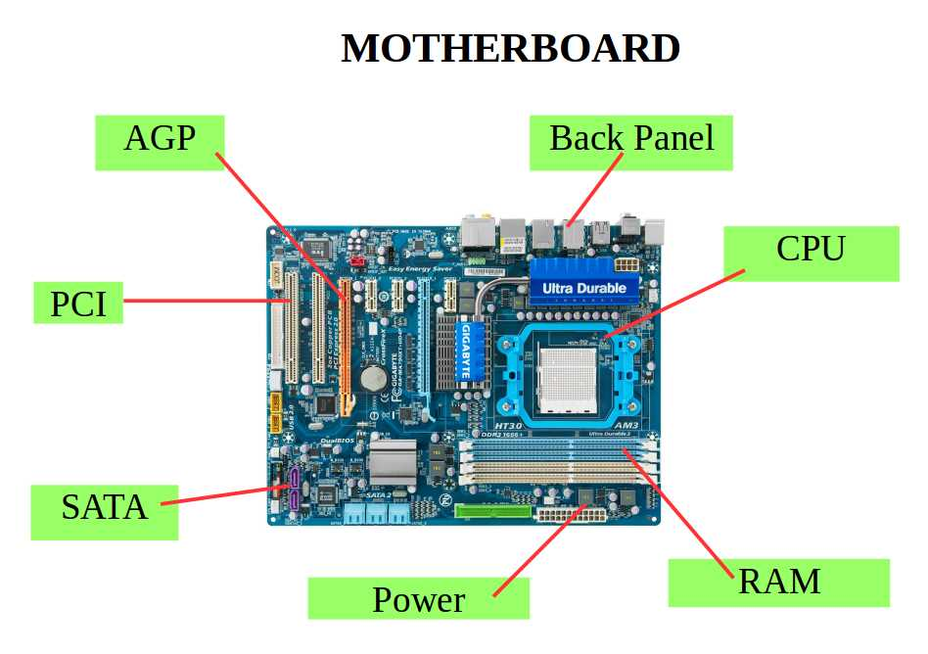

12. Demonstrate how to install a RAM module into a computer.

1. Identify RAM type – DDR3, DDR4, DDR5 (check motherboard specs).

2. Check capacity & speed – e.g., 8 GB, 16 GB, 3200 MHz

3. Match form factor – Desktop (DIMM) vs Laptop (SO-DIMM).

4. Power off & unplug computer.

5. Open case/compartment to access RAM slots.

6. Discharge static (touch metal or use wrist strap).

7. Locate correct slot – check motherboard manual for dual-channel or recommended slot order.

8. Align RAM module – notch matches slot key.

9. Insert firmly – press evenly until side clips lock.

10. Double-check seating – RAM should be flush, clips fully engaged.

11. Close case/compartment.

12. Power on and enter BIOS/UEFI to verify recognition.